**Project Design Phase-II**

**Data Flow Diagram & User Stories**

|  |  |
| --- | --- |
| Date | 03 November 2022 |
| Team ID | PNT2022TMID42716 |
| Project Name | Gas Leakage Monitoring and Alerting System |
| Maximum Marks | 4 Marks |

**Gas Leakage Monitoring and Alerting System :**

This system provides the information such as when a gas leakage is. noticed, sensors of in the project are used to notice the gas leakage and immediately turns ON the buzzer for the danger. indication. Buzzer is a clear indication of gas leakage. By the detection of the hazardous gas the alerting message.

**Example:** [**(Simplified)**](https://developer.ibm.com/patterns/visualize-unstructured-text/)

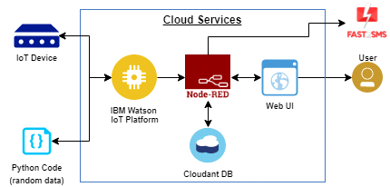

**User Stories**

Use the below template to list all the user stories for the product.

|  |  |  |  |  |  |  |
| --- | --- | --- | --- | --- | --- | --- |
| User Type | Functional  Requirement  (Epic) | User Story  Number | User Story / Task | Acceptance criteria | Priority | Release |
| Customer  (Mobile user) | Registration | USN-1 | As a user, I can register for the application by  entering my email, password, and confirming my password. | I can access my account /  dashboard | High | Sprint-1 |
|  | Login | USN-2 | As a user, I will receive confirmation email  once I have registered for the application | I can login using my email  Id accounts are user credentials | High | Sprint-1 |
|  | Dashboard | USN-3 | As a user, I can register for the application Through Facebook | I can access my account /  dashboard | High | Sprint-2 |
| Customer (Web  user) | Registration | USN-4 | As a user, I can register for the application through Gmail | I can register using my  username and password | High | Sprint-3 |
|  | Login | USN-5 | As a user, I can log into the application by  entering email &password | I can login my user  credentials | High | Sprint-3 |
|  | Dashboard | USN-6 | As a user, I can view the web application  where I can upload my image and the gas  should be recommended | I can access my account /  dashboard | High | Sprint-4 |
|  |  | USN-7 | As a user, the gas recommended to me should be of higher accurancy | I can access my account /  dashboard | High | Sprint-4 |
| Administrator | Login | USN-8 | As a admin, I can login to the website using my login credentials | I can login to the website using my login  credentials | High | Sprint-5 |
|  | Dashboard | USN-9 | As a admin, i can view the dashboard of  the application | I can access  My dashboard | High | Sprint-5 |